**PROJECT REPORT**

# **A CRM APPLICATION FOR SCHOOLS / COLLEGES**

**TEAM ID :NM2023TMID07437**

# **1. INTRODUCTION 1.1Overview**

CRM is – customer relationship management. CRM higher education technology enables institutions to manage relationships with all of their customers ( including students, alumni, faculty, staff and corporate partners ) and connect insights from those interactions in a unified view.

# **1.1 Purpose**

Using a CRM system provides educational organization with the data they need to make informed decisions about recruitment, marketing and other key areas. It also allows you to improve student engagement by tracking student interactions and providing personalized communication.

# **1. PROBLEM DEFINITION & DESIGN THINKING**

**2.1 Empathy map**

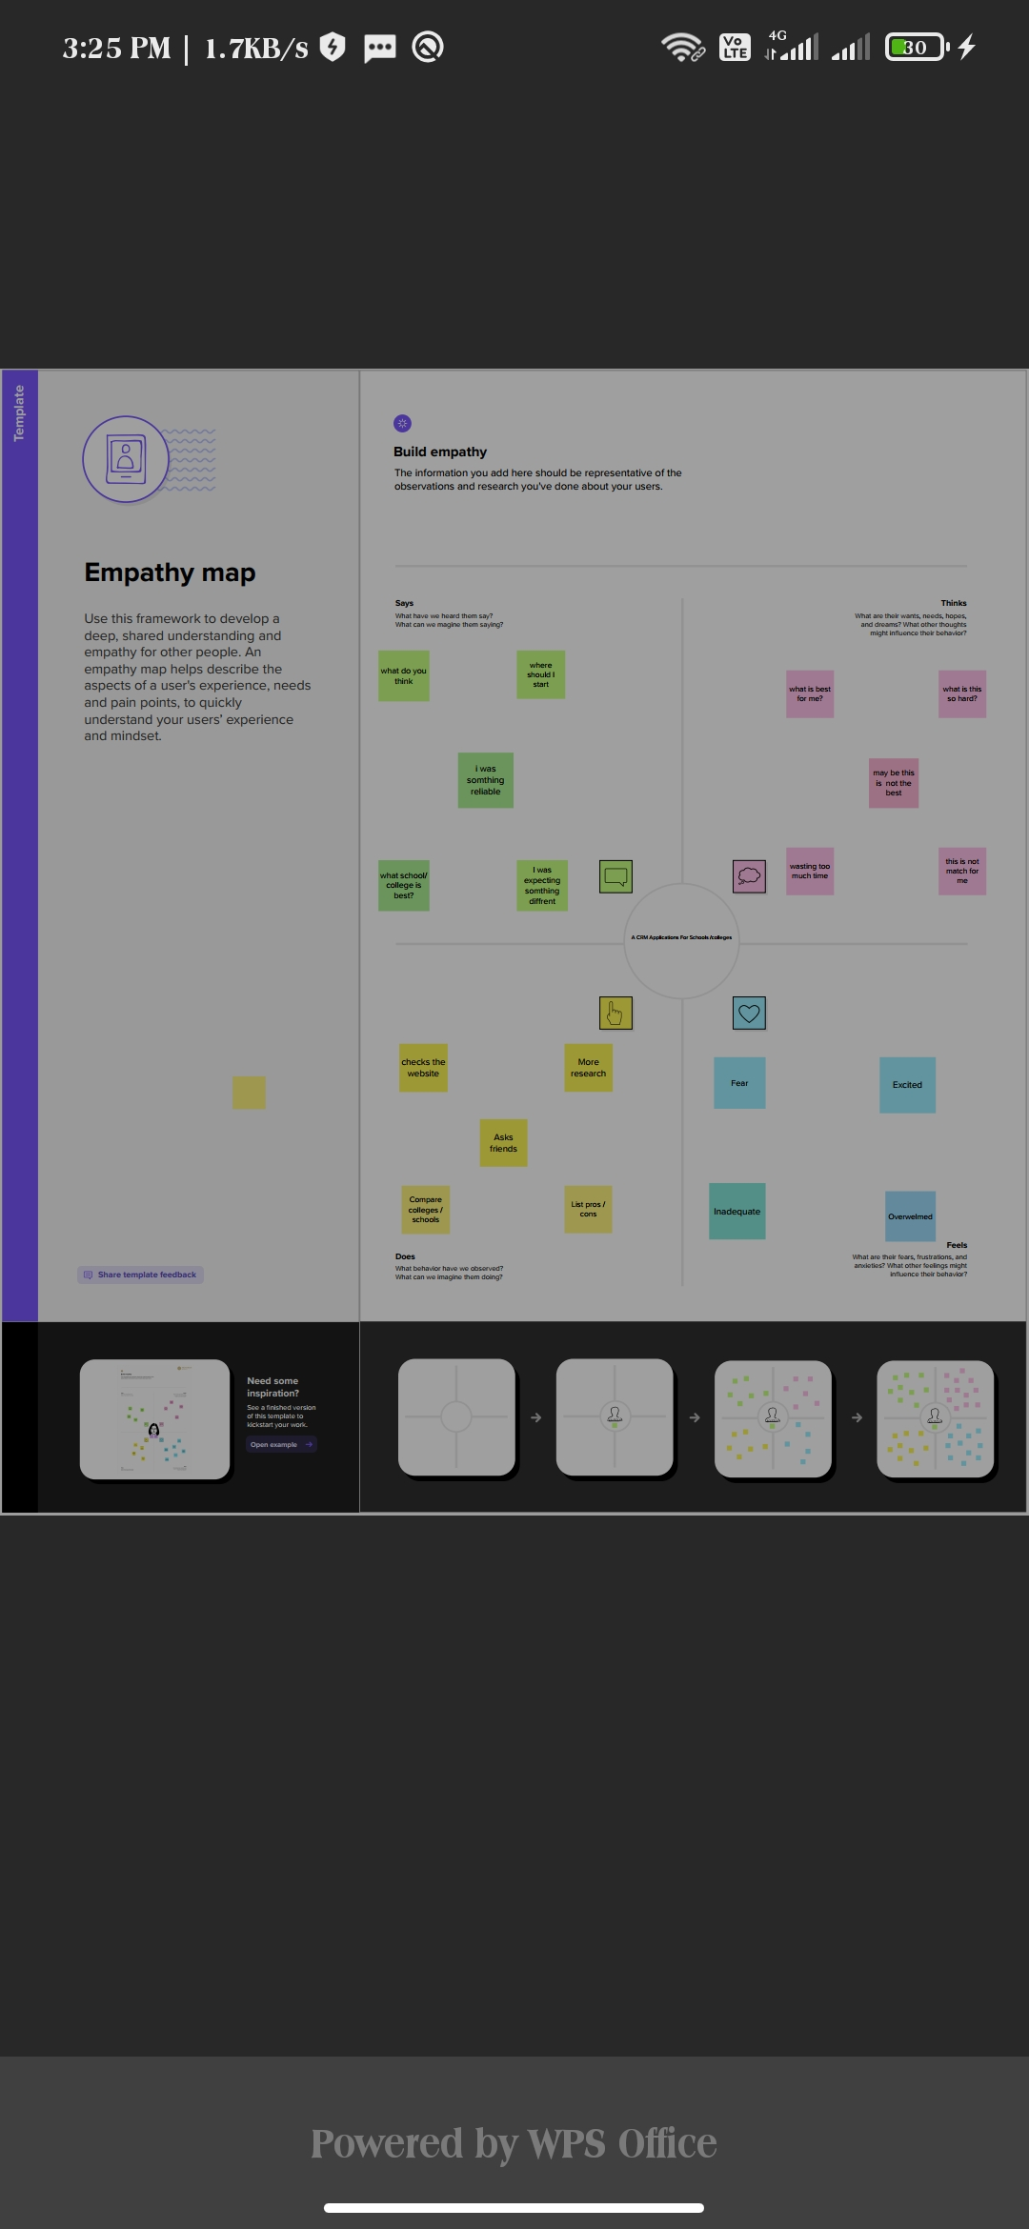

# **2.2 Brainstorming map**

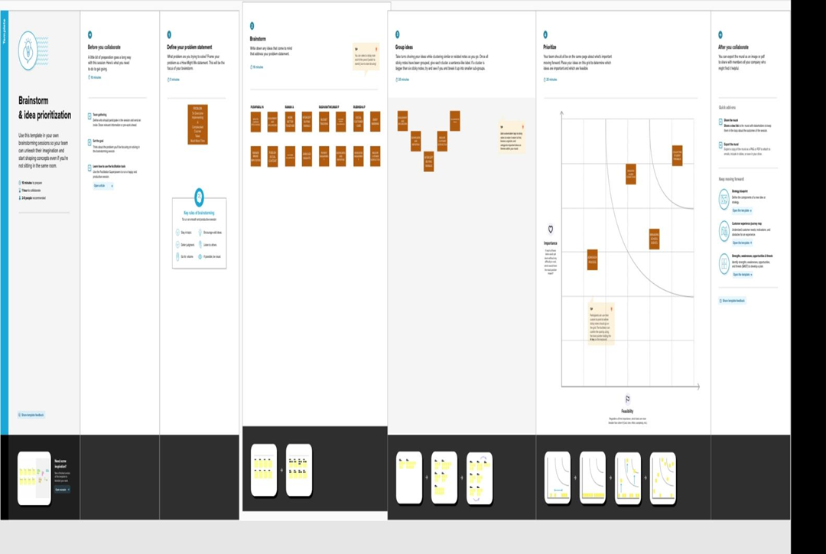

**3.Result**

**3.1 Data model**

|  |  |  |
| --- | --- | --- |
| **Object name** | **Field label** | **Data type** |
| **School object** | Address | Text Area |
| Number of students | Roll-up summary |
| **Student object** | Phone number | Phone |
| Results | Picklist |

**3.1 ACTIVITY & SCREENSHOT**

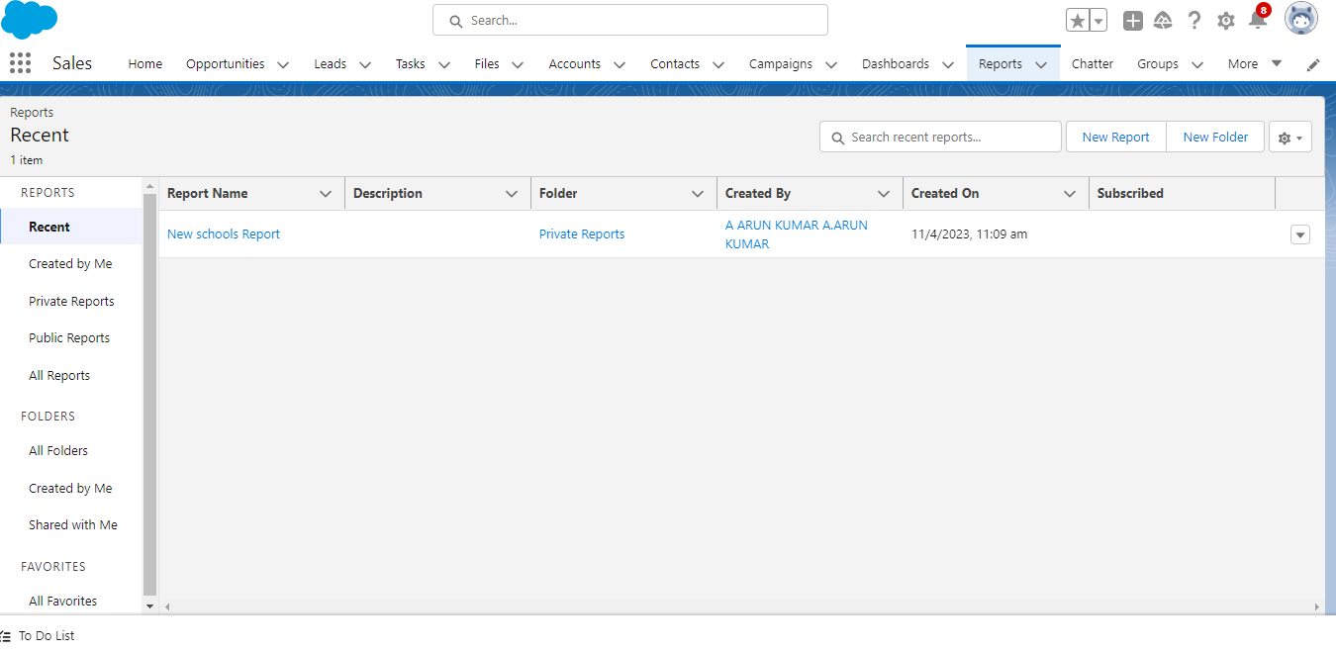

# **4. TRAILHEAD PROFILE PUBLIC URL**

Team lead - <https://trailblazer.me/id/mbabu201>

Team Member 1 - https://trailblazer.me/id/aakash368

Team Member 2 - <https://trailblazer.me/id/aedison6>

Team Member 3 - <https://trailblazer.me/id/akumar8350>

**5. ADVANTAGES & DISADVANTAGES**

## Advantages :

* Track potential leads

* Handle student enquiries

* Streamline teacher evaluations

* MIS reports

* Enrich student lifecycle management

* Build long lasting alumni relations

* Monitor fee payments & remainders

* Manage admissions

## **Disadvantages**

* Lack of communication

* Lack of organization wide use

* Lack of technology integration

* Cost

* Set clear objectives

* Deployment type

* Training

* Plan out integration needs in advance

# **1. APPLICATIONS**

* The use of CRM in education industry is important for many reasons. A CRM system can help educational organizations effectively manage and track leads, resulting in improved enrolment numbers.
* Using a CRM system provides educational organization with the data they need to make informed decisions about recruitment, marketing, and other areas.

* It also allows you to improve student engagement by tracking student interactions and providing personalised communication.
* A CRM system is an essential tool for any educational organization to improve enrolments, lead management, communication and student engagement.

# **2. CONCLUSION**

From the above discussion it is clear that every educational system must adopt CRM system for the record breaking enrollments and for managing their account as well.

# **3. FUTURE SCOPE**

The goal of the future of CRM is to make integrated sales, marketing, service and commerce possible for all companies. The project has a very vast scope in future.